Course Name: | Artificial Intelligence Laboratory | Semester: | VI
Date of Performance: | 26 / 02 / 2026 | DIV/ Batch No: | A1
Student Name: | Aaryan Sharma | Roll No: | 16010123012

Experiment No:4

Title: Implementation of informed search algorithms
Aim: Implementation of informed search algorithm (Greedy Best First search/A*)

Objectives of the Experiment:
By the end of this experiment, students will be able to:
- To understand and implement informed search techniques such as Greedy Best First Search and A* algorithm for solving problem-solving tasks using heuristic functions.
- To analyze the role of heuristic functions in guiding search and compare the performance of Greedy Best First Search and A* in terms of optimality and path cost.

COs to be achieved:
CO2: Analyze and solve problems for goal-based agent architecture (searching and planning algorithms)

Books/ Journals/ Websites referred:
- https://www.geeksforgeeks.org/dsa/greedy-best-first-search-algorithm/
- https://www.geeksforgeeks.org/dsa/a-search-algorithm/

Theory:

Problem-Solving Agent
A problem-solving agent is designed to find solutions to well-defined problems. This agent typically follows these steps:
- Formulate the Problem: Define the initial state, goal state, and possible actions.
- Search for a Solution: Use an appropriate search strategy to explore the problem space.
- Execute the Solution: Apply the sequence of actions derived from the search.
Informed Searching Technique
Greedy Best-First Search:
- Chooses the path that appears closest to the goal using a heuristic.
- Quick but might not find the optimal path.
A* Search:
- Combines path cost and heuristic to find the best path.
- Ensures the optimal path if the heuristic is accurate.
Problem Statement: The 8–puzzle problem consists of a 3×3 grid with eight numbered tiles and one blank space. The objective is to transform a given initial configuration into a specified goal configuration by sliding tiles into the blank space using valid moves (Up, Down, Left, Right). The solution must be obtained using informed search algorithms such as Greedy Best First Search or A* while minimizing the path cost.
State-space tree:
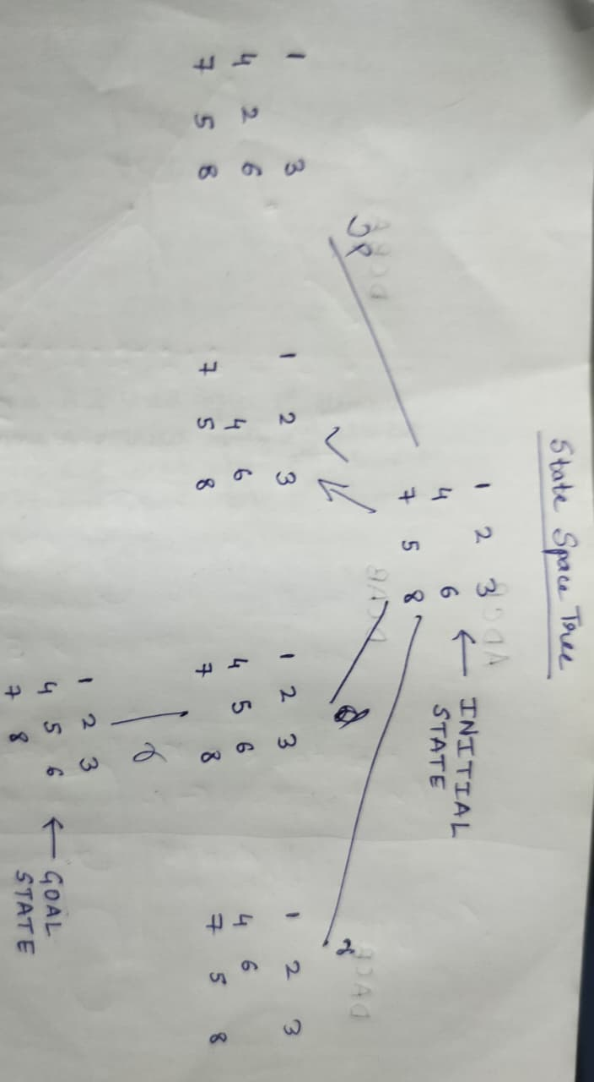Solution with of chosen algorithm on the state-space tree:
GBFS
#include <iostream>
#include <vector>
#include <cmath>
using namespace std;
vector<vector<int>> goal = {
{1,2,3},
{4,5,6},
{7,8,0}
};
int manhattan(vector<vector<int>> &state){
int dist = 0;
for(int i=0;i<3;i++){
for(int j=0;j<3;j++){
if(state[i][j] != 0){
int val = state[i][j];
int tx = (val-1)/3;
int ty = (val-1)%3;
dist += abs(tx-i) + abs(ty-j);
}
}
}
return dist;
}
void printState(vector<vector<int>> &state){
for(auto row:state){
for(auto val:row)
cout<<val<<" ";
cout<<endl;
}
}
int main(){
vector<vector<int>> initial = {
{1,2,3},
{4,0,6},
{7,5,8}
};
cout<<"Initial State:\n";
printState(initial);
cout<<"Heuristic: "<<manhattan(initial)<<"\n\n";
int dx[4] = {-1,1,0,0};
int dy[4] = {0,0,-1,1};
string dir[4] = {"UP","DOWN","LEFT","RIGHT"};
int x,y;
for(int i=0;i<3;i++)
for(int j=0;j<3;j++)
if(initial[i][j]==0){
x=i; y=j;
}
vector<vector<vector<int>>> children;
vector<int> heuristics;
cout<<"Level 1 Branches:\n\n";
for(int i=0;i<4;i++){
int nx = x + dx[i];
int ny = y + dy[i];
if(nx>=0 && nx<3 && ny>=0 && ny<3){
vector<vector<int>> newState = initial;
swap(newState[x][y], newState[nx][ny]);
children.push_back(newState);
heuristics.push_back(manhattan(newState));
cout<<"Move: "<<dir[i]<<"\n";
printState(newState);
cout<<"Heuristic: "<<manhattan(newState)<<"\n\n";
}
}
int bestIndex = 0;
for(int i=1;i<heuristics.size();i++)
if(heuristics[i] < heuristics[bestIndex])
bestIndex = i;
cout<<"NOT CHOSEN BRANCHES\n\n";
for(int i=0;i<children.size();i++){
if(i != bestIndex){
printState(children[i]);
cout<<"Heuristic: "<<heuristics[i]<<"\n\n";
}
}
cout<<"CHOSEN BRANCH (GBFS)\n\n";
printState(children[bestIndex]);
cout<<"Heuristic: "<<heuristics[bestIndex]<<"\n\n";
vector<vector<int>> next = children[bestIndex];
int bx,by;
for(int i=0;i<3;i++)
for(int j=0;j<3;j++)
if(next[i][j]==0){
bx=i; by=j;
}
swap(next[bx][by], next[bx][by+1]);
cout<<"Move: RIGHT\n";
printState(next);
cout<<"Heuristic: "<<manhattan(next)<<"\n\n";
cout<<"Goal Reached.\n";
return 0;
}
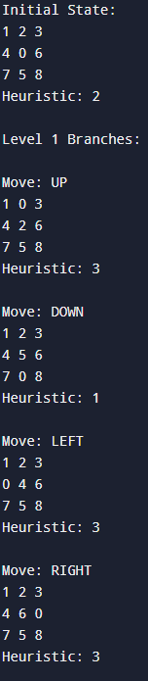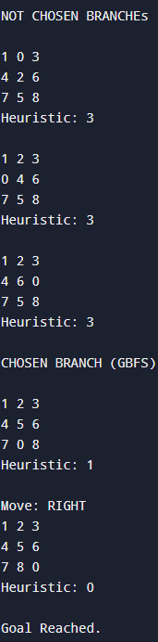
A*

#include <iostream>
#include <vector>
#include <queue>
#include <set>
#include <cmath>
using namespace std;
vector<vector<int>> goal = {
{1,2,3},
{4,5,6},
{7,8,0}
};
struct Node {
vector<vector<int>> state;
int g,h,f;
vector<vector<vector<int>>> path;
bool operator>(const Node &other) const {
return f > other.f;
}
};
int manhattan(vector<vector<int>> &state){
int dist = 0;
for(int i=0;i<3;i++){
for(int j=0;j<3;j++){
if(state[i][j] != 0){
int val = state[i][j];
int tx = (val-1)/3;
int ty = (val-1)%3;
dist += abs(tx-i) + abs(ty-j);
}
}
}
return dist;
}
string serialize(vector<vector<int>> &state){
string s="";
for(auto &row:state)
for(auto &val:row)
s+=to_string(val);
return s;
}
void printState(vector<vector<int>> &state){
for(auto &row:state){
for(auto &val:row)
cout<<val<<" ";
cout<<endl;
}
cout<<endl;
}
void astar(vector<vector<int>> initial){
priority_queue<Node, vector<Node>, greater<Node>> pq;
set<string> visited;
Node start;
start.state = initial;
start.g = 0;
start.h = manhattan(initial);
start.f = start.g + start.h;
start.path.push_back(initial);
pq.push(start);
cout<<"Initial State:\n";
printState(initial);
cout<<"Goal State:\n";
printState(goal);
while(!pq.empty()){
Node current = pq.top();
pq.pop();
string key = serialize(current.state);
if(visited.count(key)) continue;
visited.insert(key);
if(current.state == goal){
cout<<"Optimal Path:\n\n";
int step = 0;
for(auto &state : current.path){
cout<<"Step "<<step<<":\n";
printState(state);
cout<<"g="<<step
<<" h="<<manhattan(state)
<<" f="<<(step + manhattan(state))
<<"\n\n";
step++;
}
return;
}
int dx[4] = {-1,1,0,0};
int dy[4] = {0,0,-1,1};
int x,y;
for(int i=0;i<3;i++)
for(int j=0;j<3;j++)
if(current.state[i][j]==0){
x=i; y=j;
}
for(int i=0;i<4;i++){
int nx = x + dx[i];
int ny = y + dy[i];
if(nx>=0 && nx<3 && ny>=0 && ny<3){
vector<vector<int>> newState = current.state;
swap(newState[x][y], newState[nx][ny]);
if(!visited.count(serialize(newState))){
Node next;
next.state = newState;
next.g = current.g + 1;
next.h = manhattan(newState);
next.f = next.g + next.h;
next.path = current.path;
next.path.push_back(newState);
pq.push(next);
}
}
}
}
cout<<"No solution\n";
}
int main(){
vector<vector<int>> initial = {
{1,2,3},
{4,0,6},
{7,5,8}
};
astar(initial);
return 0;
}
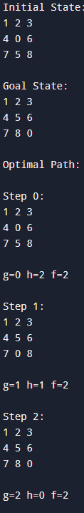
Comparison of performance of Greedy and A* Algorithm:
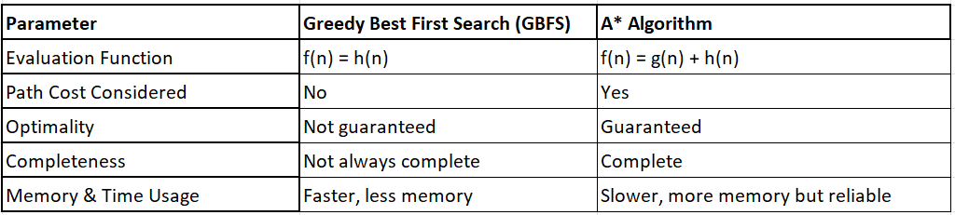
Properties of A* algorithm:
Complete: A* always finds a solution if one exists.
Optimal: It guarantees the optimal solution when the heuristic is admissible.
Evaluation Function: Uses
𝑓(𝑛)=𝑔(𝑛)+ℎ(𝑛)
where 𝑔(𝑛) is path cost and ℎ(𝑛) is heuristic.
Admissible Heuristic: The heuristic never overestimates the true cost to reach the goal.
Time and Space Complexity: Both are exponential in the worst case since it stores generated nodes.

Post Lab Subjective/Objective type Questions:
Question: Answer in brief
- What is an informed search algorithm? How does it differ from uninformed search methods?
An informed search algorithm uses a heuristic function to estimate the distance from the current state to the goal state, helping guide the search more efficiently. Unlike uninformed search methods such as BFS and DFS, which explore blindly without additional knowledge, informed search algorithms use problem-specific information to reduce unnecessary exploration and reach the goal faster.

- Find a good heuristic function for following
- Monkey and Banana problem
A good heuristic is the number of actions required to reach the banana, such as the distance between the monkey and the box plus the distance between the box and the banana. This estimates how far the monkey is from achieving the goal.
- Travelling Salesman problem
A good heuristic is the minimum spanning tree (MST) cost of the remaining unvisited cities or the straight-line distance to the nearest unvisited city. These estimates help approximate the remaining travel cost.

- How does A* avoid exploring unnecessarily expensive paths compared to Greedy Best First Search?
A* uses the evaluation function
f(n) = g(n) + h(n),
where g(n) is the path cost so far and h(n) is the heuristic estimate. By considering both the actual cost and estimated cost, A* avoids paths that appear close to the goal but are actually expensive. In contrast, Greedy Best First Search considers only h(n), which may lead to suboptimal or costly paths.

Conclusion:
In this experiment, informed search algorithms Greedy Best First Search and A* were implemented to solve the 8-puzzle problem using the Manhattan distance heuristic. The experiment demonstrated how heuristic functions guide the search toward the goal efficiently. Greedy Best First Search provided faster decisions but did not guarantee optimality, whereas A* ensured the optimal path by combining path cost and heuristic value. This experiment helped in understanding the importance of heuristic functions and their impact on search performance in goal-based agent architectures.

